

Lions District 202D
2024 - 2025
YOUTH HANDBOOK
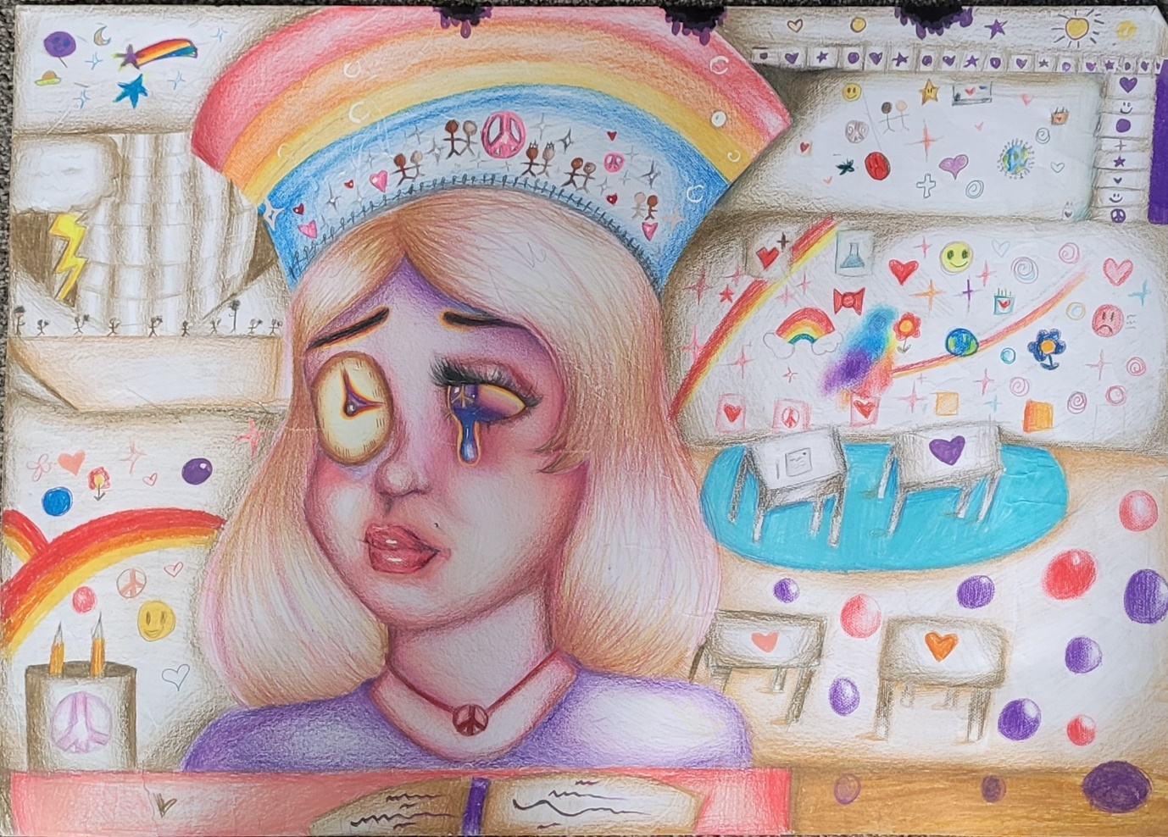
2023/24 202d District Winner: Bella Galloway (12 years), Kaponga Lions
Youth Chairman North Youth Chairman South Stephanie Jordan Robyn Pederson
46 Fairfield Road, Hawera, 4610 12 Sunshine Place, Kelvin Grove
Hawera, 4610 Palmerston North, 4414
Cell: 022 054 0515 Cell: 027 494 7125
Email: 202d.youthnorth@lionsclubs.org.nz Email: 202d.youthsouth@lionsclubs.org.nz

District Governor: Denis Hurcomb
202d.dg@lionsclubs.org.nz
021 076 3367
The information contained in this booklet is confidential and for the use of Lions members exclusively. Under no circumstances should it be used for commercial purposes, nor should they allow the use by others.

YOUTH ACTIVITIES PROGRAMME 2024-25
2024
July - August Winter Exchange (Inward) Hosting required
Hosting Canada, USA and Europe
July - August Youth Exchange (Outward)
Applications with $1000 Deposits close on 31/08/24
August – September Summer Exchange (Inward)

September-October National Youth Camp – Kaiteriteri 29th Sept to 5th October

October District Peace Poster Contest entries close 25/10/24. Judging from 1/11/24

October Junior Speechmaker Competition entries close 25^{h} October

November Junior Speechmaker Competition (10 – 13-year olds) to be held at the Community Centre in Hawera at 9.30am for 10:00am start on Sunday the 3rd of November.

November Orientation for Outward Exchanges.
November Young Leaders in Service Awards: Entries close 15/12/24.
December – January Summer Exchange Youth Arrive CANCELED THIS YEAR
Hosting required. Looking at City/Country exchange between clubs
December – January District 202L Lions International Youth Camp NZ held at Ngamuwahine Outdoor Education Lodge, Tauranga. CANCELED THIS YEAR
2025
January 202D Youth Award Entries closes 31/01/25.
March Peace Poster Theme announced. (Competition age 11 – 13)
Schools should be contacted as soon as possible
March – July Winter Exchange (Inward) Hosting required for July/August
Hosting Japan, Canada, USA and Europe primarily.
May Young Speechmakers Contest. Sunday 25th May 2025. (aged 16-21)
June Children of Courage Awards – 8th June

Youth Directors – Information on the Speechmaker Contests, Youth Exchange, Peace Poster and International Youth Camp can be found on the National Lions website – www.lionsclubs.org.nz. Simply go to site map and click on Youth.

District 202D Junior Speechmaker Competition

This is a 202D District Project designed to encourage speechmaking for students in Years 7 and 8.

Each contestant will prepare and present a three-minute speech (2-minute warning given) on any chosen topic. All contestants will be required to do an impromptu speech of 1 minute duration with the topic chosen on the day by the judges.
The impromptu speeches will take place following the lunchbreak.

Your club can be involved:
- By promoting the project in your communities, at your local schools – please note the year 7 & 8 age restriction.
- Work with your local schools to obtain and screen contestants (ensuring entrants are in good health and of good character)
- Pay the entrance fee of $50 (Online banking 03 0791 0232608 05. Ref Club Name)
- To ensure all documentation and payment is lodged with District Youth Chairman by stipulated date.
- To arrange transport for contestant/s to District contest if necessary and support as required.
- To inform their contestants of all relevant details regarding the conditions of the contest

The contest will be held at “The Community Centre” in Hawera on Sunday 5th November from 9:30am for registrations. Morning tea will be available. Speeches will begin promptly at 10.00am.
Mt View Lions Club will provide morning tea and lunch for $10 for visitors and friends, payable at the door. Please support them and let the contestant’s families and your club members know. Lunch tickets can be purchased on the day. Please note, Lunch for the contestants is included in the entry fee.

As a sponsoring club you are taking responsibility for the youth you are sponsoring. This means keeping the youth and their family informed and arranging travel for them if required. It is also customary that your club cover the lunch costs for your youth’s attending family. Your responsibility does not end after you complete the entry form and send it to the youth chairs. For further information please contact either youth chair to assist you.
Entry's close Friday 25th October
Please post entry forms and pay online to:

Youth Chairman North Youth Chairman South
Stephanie Jordan Robyn Pederson
46 Fairfield Road 12 Sunshine Place, Kelvin Grove
Hawera 4610 Palmerston North 4414
Cell: 022 054 0515 Cell: 027 494 7125
Email:202d.youthnorth@lionsclubs.org.nz Email: 202d.youthsouth@lionsclubs.org.nz

DISTRICT 202D JUNIOR SPEECHMAKER
APPLICATION FORM
Date: Sunday 3rd November 2024
Venue: Hawera Community Centre
Time: 9.30 am Registrations , Speeches Start 10am
The Mt View Lions Club will provide morning tea and lunch for $10. Please support them.
(Lunch for the contestant is included in the registration fee)
Application Data:
Surname: Male/Female
First name:
Address:
Telephone: ( ) Email
Date of Birth: / /
School:
Year Level:
Theme of Speech:
Approval
Parent’s Signature: Date:
Student’s Signature:
Sponsoring Club:
Signature of President, Secretary or Director of Sponsoring Club:
Date:
- Entry Fee of $50
- Make online payable to District 202D Lions. (03 0791 0232608 05)
- Entry fee includes lunch – Payable by the sponsoring Lions Club.
Please post or scan and email to either:

Youth Chairman North Youth Chairman South
Stephanie Jordan Robyn Pederson
46 Fairfield Road 12 Sunshine Place, Kelvin Grove
Hawera 4610 Palmerston North 4414
Cell: 022 054 0515 Cell: 027 494 7125

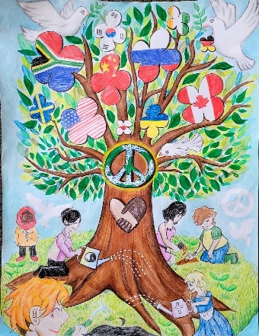
Peace Poster Competition

The theme for the 2024-2025 Peace Poster
“PEACE WITHOUT LIMITS​”
Entry eligibility: Age 11 – 13 as of 15 November

- Clubs may purchase Peace Poster kits https://www.lionsclubs.org.nz/shop/peace-poster-kit between Jan 15 & 1 Oct.
- Schools should be contacted early March 2024
- All Posters MUST​ be made to required size – anything different will not be accepted. THIS​ IS VERY IMPORTANT!!!!!!!
- Club to provide students with A2 size (420mmx594mm) acid & lignin free art paper no less than 100gsm in weight. This can be purchased from Warehouse Stationary.
- All entries must be flexible enough to be rolled up for shipping in 6cm diameter tubes.
- Pencils, pens, crayons, markers, paint, or chalk may be used. Entries should be sprayed to prevent smearing.
- 3D entries will not be accepted. Nothing may be glued, stapled or attached to the artwork in any way.
- Signatures or initials and brief description should be written on the back of the artwork. (See attachment).
- NO LETTERING OR NUMBERS ALLOWED ON THE POSTER
- Posters must not be laminated.
- Closing date for District judging is 25/10/24. District judging takes place from 30th October. Vouchers will be awarded to the first three places in the district.
- Closing date for the Multiple District Judging is 1/12/24. The winning entry for the district goes forward to this competition.
- One grand prize winner (Worldwide) receives US$5000, a plaque and a trip for two family members to attend the International Awards ceremony at Lions Day with the United Nations
(Subject to change). Each of the 23 merit award winners will receive a cash award of US$500 and a certificate of achievement.

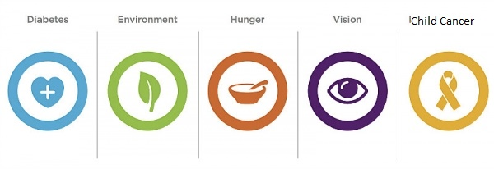

- All entries must be forwarded to Youth Chairmen, Stephanie Jordan & Robyn Pederson before closing date.
Leo Clubs
Leading for Life
Alpha Leos aged 12-18 years
Omega Leos aged 18-30 years

Leo clubs are sponsored by local Lions clubs through Lions Clubs international. The first Leo club was started in 1957 by the Glenside Lions Club in Pennsylvania, USA and there are now more than 7000 Leo clubs in approximately 145 countries.

We have 30 Leo clubs spread throughout New Zealand with three in our district; two in Palmerston North and one in Kairanga.


Their activities include guest speakers, visiting the elderly, general community service, fundraising, helping with local Lions club projects and having FUN!

Consider starting up a Leos Club in your local community or local school. The Leos are sponsored by a Lions club so there is no cost for them to join.

The Leo Club programme can increase Lions community exposure, attracting potential members such as professionals, parents and families.

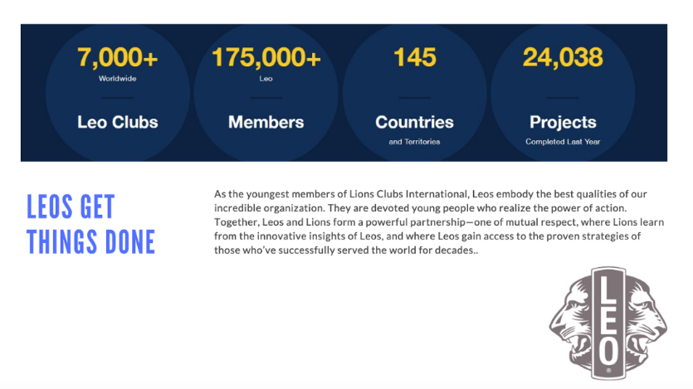
For more information please contact

Robyn Pedersen
Leo Co-ordinator
Email hipchick1000@gmail.com
Ph (06)3578975
Cell 027 494 7125

LIONS YOUNG LEADERS IN SERVICE AWARDS
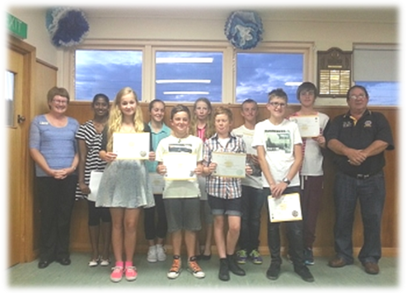

This award recognises youth aged from 12 years old for their commitment to community service over a eleven month period from February 1st to December 15th each year.

There are two awards available:
- 50 hours of community service
- 100 hours of community service

Types of service could be:
- Community groups, religious agencies, or institutions
- Service through a school-based group or courses
- Individual efforts to help others. E.g., Coaching or refereeing of sports
- Scouting groups
- St John
Why not invite your children/ grandchildren along to help in your club’s service activities and get them involved with Lions now?

All you must do is supply applicants with a Service Tracking record form. These are available from your Youth Chairman so that progress can be monitored.

The forms must be collected before the closing date of December 15th of each year and returned to your District Youth Chairman. The certificate will arrive directly to your club. You will need to organise a time to present the certificate to your applicant, perhaps at a club meeting would be suitable.

The District Youth Chairperson would like to attend a presentation where possible.


This can be a steppingstone to further youth activities both within your club and for the youth involved.

LIONS YOUNG LEADERS IN SERVICE AWARD:
Youth Service Tracking Sheet:
(For participating Youth)

______________________________ Lions Club is recognizing young people for their service to the community. Use this form to record service hours to be considered for the Lions Young Leaders in Service Award. Please return completed form to ________________________________by 15th December 2024.

…………………………………………………………………………………………………………………….
First Name Last Name

…………………………………………………………………………………………………………………….
Street Address

……………………………………………………………………………………………………………………..
Phone Number Email: Age M/F
Date Service Activity Code Location Hours Sign

TOTAL HOURS: ______________

Service Activities Codes:

1. Diabetes 2.Vision 3.Hunger 4.Paediatric Cancer 5. Environment 6.Other

Youth Signature ___________________________________________________________Date___________________

Parent/Guardian ________________________________________________________Date __________________

DUFFY BOOKS IN HOME PROGRAMME
The Duffy Books in Homes programme was inspired by Alan Duff who, with the help of Christine Fernyhough, developed the idea after realising that failures in adult life often stem from childhoods spent in bookless homes. The philosophy behind the programme is simple - to break the cycle of 'booklessness'. Kids who can't read become adults who can't communicate and that's a serious disadvantage in a world that operates on the written word.

The schools are selected from areas where the children are most likely to come from ‘bookless homes’. The Ministry of Education allocates schools a decile rating of between 1 and 10, according to the socio-economic status of the community in which a school is based. Duffy Books in Homes focuses on lower decile schools. Why? Because over half the parents in decile 1 catchments are without a school qualification. Furthermore, 42 percent of parents in decile 1 catchments received income support in the year preceding the 1996 Census, compared to just 7 percent for decile 10 catchment areas. Quite simply, the children from these schools are most likely to come from bookless homes.

Alan's self-help philosophy is reflected by the fact that each school joins in a financial partnership with their sponsors to fund their books. The books are selected by the children themselves and are theirs to take home and keep. Each book has a sticky label which has the child's name in it as well as the name of the school and sponsor who have given the book. In 2014, the programme celebrated 20 years of operation and gave away its ten millionth book.

Twice a year special Role Model Assemblies are held at every school. Sportspeople, musicians, artists, writers, radio personalities, television presenters, fashion designers and many other New Zealanders visit Duffy schools, present books and talk to the children about their achievements and goals. The message is simple, "It's Cool to Read". Website: http://www.booksinhomes.org.nz

Taranaki  Schools | Eltham Primary School, Huirangi School, Manaia Primary School, Mokau School, Ngamatapouri School, Normanby School, Patea Area School, Ramanui School, St. Joseph’s School (Waitara), Te Kura Kaupapa Maori Ngati Ruanui, Te Pihipihinga Kakano Mai l Rangiatea Kura Kaupapa Maori, Waitara East School, Waitotara School, Waverley Primary School,
Wanganui  Schools | Aberfeldy School, Aranui School, Carlton School, Churton School, Keith Street School, Ohakune School, Okoia School, Orautoha School, Te Kura Kaupapa Maori o Te Atihaunui-A-Paparangi, Te Kura Kokohuia, Te Kura o Ratana, Te Wainui a Rua School, Upokongaro School, Wanganui East School.
Manawatu  Schools | Hillcrest School, James Cook School, Levin East School, Marton Junction School, Marton School, North Street School, Otaki School, Papatawa School, Raetihi School, Roslyn School, Somerset School, Taoroa School, Te Kura o Takaro, Woodville School.

How You Can Support the Programme:

There are several ways of supporting Duffy Books in Homes. You may wish to sponsor a school and enjoy the partnership that develops as a result. Or you may wish to make a donation towards the cost of the books for unsponsored schools and various other elements of the Duffy Books in Homes programme.
Please feel free to approach your local school to offer your help or make contact with the coordinators as detailed below.

Any contribution is welcome and appreciated. For more information:
Phone: 0800 383 392
Fax: 09 270 7416 Email: duffy@booksinhomes.org.nz


CAMP QUALITY
Kids Cancer – Think Camp Quality
WELLINGTON CENTRAL DISTRICTS

Camp Quality (New Zealand) Incorporated is a Charitable Trust established in 1985.

At Camp Quality we are dedicated to bringing fun, hope and happiness to the lives of children aged 5 to 16 living with cancer, their families and communities, through provision of high quality recreational experiences. Our goal is to provide fun and comradeship combined with achievable challenges to encourage the children to focus on the positive aspects of their lives. Camp Quality passionately believes in the power of fun to help children and their families overcome the challenges that cancer brings.

We ran our first camp in West Auckland in January 1985, which was attended by 22 children throughout New Zealand. Since then we have grown to have regular camp locations situated in:
- Auckland/Northland
- Waikato/Bay of Plenty
- Wellington/Central Districts
- Christchurch
- South

Each year more than 300 children aged from 5 to 16 years attend one of our camps. We are a totally voluntary organisation with no individual receiving remuneration. Thousands of hours each year go into raising funds and organising our programmes. Any child may attend a camp if they have been affected with cancer. We have campers who are in remission or on maintenance programmes attending our camps. Each camp has a minimum of two Paediatric Oncology trained staff in attendance. In some circumstances siblings are also able to attend our programmes. We strive to provide a safe and secure environment involving one-on-one support from companions and by the provision of committed, well-trained staff on all of our camping activities. All volunteers who are staying on camp must undergo a police vetting check and attend an annual training programme.

Camp Quality was the inspiration of an English woman, Vera Entwhistle, who in 1983 established a special adventure camp for children with cancer, in Australia.

The area of Wellington Central Districts encompasses the Lions Districts of 202D and 202M. Wellington Central Districts caters for approximately 70 children at summer camp for an annual budget of $100,000 plus. This is about $2,700 per camper and includes all costs incurred for running the camp….meetings and trainings included. Our Lions Clubs have made these camps possible by generous donations of both money and time. Not only do these camps provide the children a week of “quality life”, but also their parents a well-deserved rest.

The camp this year will be held -New Plymouth Central Districts Region Summer Camp 2025: 12-17 Jan at New Plymouth Boys High School.

If any club would like a visit from a staff member or require further information please contact:

Regional Manager  Matt Perkins  rm.central@campquality.org.nz | 202D Co-ordinator  Michelle Hofmans  027 5317684  michelle@mgfn.co.nz


LIONS DISTRICT 202D
YOUNG SPEECHMAKER CONTEST
FOR SECONDARY SCHOOL STUDENTS / YOUNG ADULTS
AGED 16-21 (​as at 15/11/25)
202D District Final
Date Sunday 25th May 2025
Venue Waverley Primary School
Time 9.20am for a 10am start
Cost: $125 ​ (sponsorship by local Lions Club.)
Speech Criteria- a prepared speech on own chosen topic​ 6-8 minutes, as well as an impromptu speech of 1- 2 minutes. Prizes to be awarded for 1st​ ​, 2nd​ ​, 3rd​ ​. Closing date for entries Friday 9th May 2025.
We are looking for up to 2 of the best young speechmakers in our District. They have the opportunity to represent 202D at Multiple District Speechmakers Final will be held August 2025, to win a prize of $2500.00, $1000.00 for 2nd and $500.00 for 3rd.

Prepared: ​All contestants shall speak on a subject of their choice in a formal speech for no less than 5 minutes and no longer than 7 minutes. Contestants speaking less than 5 minutes and more than 7 minutes will incur time penalties.
Any subject that is the original work of the contestant may be presented. This competition requires a spoken presentation in English (New Zealand), with rap and non-English languages only acceptable as an adjunct to the main presentation in English, but must not make up more than 10% of the total speech. Original props such as posters, flash cards, images, and simple graphs or diagrams may be used to support the message of the speech. Voice projection and physical presentation of the speech is an important aspect. Contestants may use prompting notes or cards. This includes the use of mobile phones, tablets or cards as required. The prepared speech must be the original work of the speaker. They may use quotes from others but must attribute them so the source is recognized- e.g. “Winston Churchill famously said in his speech to Cambridge University in 1953, …..”

Impromptu​: The judges / adjudicators will determine the topic at the contest venue. All contestants will have the same topic and will speak in order as drawn by judges / adjudicators or organising Lions. They will come forward and be given a written ​‘starting phrase’​ of not more than five words. They will then have one minute to prepare notes prior to presenting an impromptu speech using the starting phrase lasting ​not less than one minute​, and ​no​ ​longer than two minutes.

An example of the ‘starting phrase’ could be – ​“And then she told me…”

Contestants may take the starting phrase in any direction they wish. Humour is recommended for such a short speech, but we recommend that you follow a single theme. Our advice is to not make it too complex.
In both speeches, contestants will be penalized for being under or over time. Timing lights will be used to assist speakers.
The winner will be the speaker with the ​best combined score​ from both speeches.
Judging criteria is attached for your information:

Judging Criteria. Maximum points available.
 |  | PREPARED | IMPROMPTU
Voice and grammar  (including pitch, volume, pronunciation) |  | 15 points | 8 points
Physical delivery  (including gesture, poise, assurance, enthusiasm) |  | 20 points | 10 points
Speech structure and theme development  (including opening, body, closing statement) |  | 25 points
Humour  (Impromptu only) |  |  | 12 points
Speech value  (including ideas, logic, appeal to audience, appropriateness of choice) |  | 20 points | 10 points
Confidence and voice, Clarity  (including effectiveness and achievement of purpose) |  | 20 points | 10 points
TOTAL POINTS AVAILABLE | 100 POINTS |  | 50 POINTS
GRAND TOTAL OF POINTS AVAILABLE: 150 POINTS

Judging
District Young Speechmaker Competition judges / adjudicators will be independent of the contestants and suitably qualified people. The National competition judging panel in Wellington is an experienced and independent group of judges so a high standard of performance is expected.
Prepared Speech
This is a prepared speech by the Young Speechmaker on any subject of their choice. They have to speak for not​ less than five (5) minutes, but ​not more than seven (7) ​minutes.​
Penalties are applied as follows
Under five minutes by up to 30 seconds | one penalty point
Under five minutes by more than 30 seconds | two penalty points
Over six minutes by up to 30 seconds | nil penalty points
Over six minutes 30 seconds | one penalty point
Over seven minutes | two penalty points.
This allows leeway for the 30 seconds over time so as soon as they see the red light (or are told ‘time’ if there are no lights) they have to close within 30 seconds.

Impromptu Speech
The speaker is given a sheet with a phrase written on it and has one minute to prepare an impromptu speech.
From the time the sheet is handed to them, you are to time them for one minute – they are then required to speak. They are required to speak for a minimum of one minute​ , but ​ no longer than two minutes.​
Penalties are applied as follows
Under one minute by up to 30 seconds two penalty points
Over two minutes by up to 30 seconds one penalty point
Over two minutes 30 seconds or more two penalty points
Speakers are to be warned at 90 seconds, by an orange light (or 30 seconds) that they have 30 seconds to close and again at two minutes by a red light (or time).

Intention of This Competition
This has been running as a competition for more than 30 years and has delivered some amazing outcomes for the young adults who have taken part. We want to encourage young adults the ability to:
- Have the confidence and self-assurance to stand up and speak in front of others despite any nervousness they may experience.
- Express themselves in the prepared speech on a subject that they feel passionate about. We want to encourage them to use their emotions while delivering a cogent, logical case for the audience to accept their views.
- Use the English language with fluency and conviction without the use of obscene language, meaningless words (‘like’) while using foreign languages as is normal in New Zealand society. They are permitted to use flash cards, images and graphs to support their speech.
- Deliver an impromptu speech with minimal preparation time. The use of humour is encouraged, but not mandatory. We encourage them to have a simple theme and deliver a message that draws in the audience.

Rules of the Competition
- All contestants must complete the attached application form before attending the District and National competition.
- They must meet the age limitation requirements of being 17 through to 21 on the 30​^{th​} June of the year in which they are competing.
- Previous National competition (MD202) winners may NOT compete again in following years. That rule does not apply to winners at District or Club level.
- The prepared speech must be substantially the original work of the speaker. They may use quotes from others but must attribute them so the source is recognized.
- Note the requirement that this speech is delivered in English. (see above)
- Note the judges scoring sheets attached – these are to be provided to all contestants so they are aware of what the judges are looking for. All levels of the contest will use the same judges score sheet to ensure consistency of outcomes.
- The ‘starting phrase’ for the impromptu speech is to be the same for ALL contestants. It will change between Club and District contests, and again at the National contest. It is to be typed neatly in large font and given to the speaker on a card so they have one minute to prepare some notes and thoughts before starting their presentation. The combined score from both speeches will decide the winner.
- Speaking for less than the required time or more than 30 seconds OVER time will incur penalty points. The speaker lights are to assist them in keeping track of the time and warn them of the looming deadlines so they can wrap up when needed.
- Contestants may use the same prepared speech in all levels of the competition. They are also allowed to modify it in the light of experience as they progress. Judges will often give comments and advice to the speakers and that can be legitimately used to improve their next performance.
- We encourage Lions and their families to make this an enjoyable contest for these young adults. They are always thirsty for genuine praise, so do not hesitate to encourage them and tell them what you thought of their ideas and speech. Give them helpful and constructive advice on how they can improve their next performance. This is a great chance for Lions to present a positive message to these young men and women and their parents and family in support.

For further information, the rules, entry form and completed entry form please contact:​

YOUTH NORTH YOUTH SOUTH
Stephanie Jordan Robyn Pederson
46 Fairfield Road 12 Sunshine Place, Kelvin Grove
Hawera 4610 Palmerston North 4414
Cell: 022 054 0515 Cell: 027 494 7125

APPLICATION TO COMPETE IN THE LIONS CLUB OF NEW ZEALAND YOUNG SPEECHMAKERS COMPETITION 202D District Final
Entries must be received on or before Friday 9th May 2025
Please print all details neatly.

Surname:​ Age _____________

Forenames:​ Male ​ Female​

Address:​

Telephone/Mobile: _____________ ​ Email:​______________________________________________
Secondary School, Tertiary College or Employer:​

Topic of Speech ___________________________________________________________

Career objectives:
Any special dietary requirements?

Note: that in accordance with the Privacy Laws of New Zealand, my address and contact details will remain privileged information to Lions Clubs New Zealand and not be made available in any form to the general public​.
Guardians Data (if under 18 years of age)
Name: ______________________________________________________________________________________
Relationship: Address:____________________________________________

Phone/ mobile:__________________________________________________________________

I wish to compete for the Lions Clubs of New Zealand ‘Young Speechmakers’ competition in 2023.
I understand that by signing this application form I agree that I will:
  - Comply with the rules of the competition;
  - Certify that my prepared speech is substantially my original work;
  - Agree to make myself available for Club, District and National speech competitions as far as is practical around my other commitments
  - Accept the decisions of the judging panel/s; and
  - Agree to the use of my name and image for promotion by Lions Clubs of New Zealand as a contestant and/or winner.
Your Signature: __________________________________ Date:_______________________

Sponsoring Lions Club:___________________ Name of Club President:______________

President or Secretary Signature: Date
DISTRICT 202D YOUTH AWARD
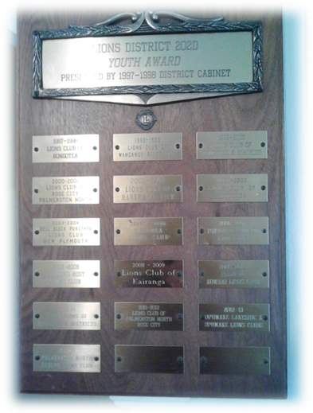
To further promote Youth activities within the District, the District Cabinet in 1997-1998 approved a District Youth Award. This award is to be awarded annually to the club who submits a Youth Activity Project (small or large) to the District Governor of the day, by the 31st January each year.
The winning entry of the District Contest will be forwarded to the Executive Officer as the District’s Entry to the Pat Ryan Youth Award, judged, and presented at the Multiple District Convention.

Aims and Objectives:
- To encourage club participation in Youth Activities
- To stimulate friendly rivalry between clubs by implementing exciting and adventurous Youth Programmes
- To enable worthy projects to be recorded and make available for use by other clubs

Entries:
- Each Club would be able to make one entry in each Lions year
- Project details should be presented on no more than two pages of A4 paper (one side only) together with such other supportive documentations and photographs as the club sees fit
- The project has to be completed the immediate prior fiscal year
- District entries must be sent to the Multiple District Secretary by the 1st March each year
- The multiple District winner will be announced at the Multiple District Convention
- Judging – Judges at District level shall be appointed by the incumbent District Governor, Judges at Multiple District level shall be appointed by the Multiple District Secretary or by the Multiple District Youth Chairman
- A constant standard of judging shall be applied, both at District and Multiple District Level on the following basis:
- Originality and initiative 35 Marks
- Benefit to participants and the community 20 Marks
- Number of youth involved 20 Marks
- Club member involvement 25 Marks

The winning entry of the District contest will be forwarded to the Multiple District Secretary as the District’s entry to the Pat Ryan Youth Award, Judged and presented at the Multiple District Convention.

CHILDREN OF COURAGE 2025
AWARDS PRESENTATION

(DISTRICT 202D)
This Photo by Unknown Author is licensed under CC BY-NC

Sunday 8th June 2025
Registration from 12.30pm
Venue to be confirmed.

INFORMATION FOR CLUB SPONSORSHIP
This information and attached forms can also be accessed online at
www.lions202d.co.nz/resources

ABOUT CHILDREN OF COURAGE
Children of Courage is NOT A COMPETITION. Every nominated child will receive an award.
In hosting this Annual Award, Lions Clubs aim to honour the individual achievements of extraordinary children in 3 categories and provide them with.
- REGOGNITION
- ENCOURAGEMENT, and
- SELF-WORTH
All children aged 5-15 years of age on 1 May 2025, who fall into one of the categories listed below and who have not previously received a Children of Courage award, are eligible for nomination. Due to hall capacity available, up to first 40 nominations only will be accepted on a first-in-best-dressed basis.

CHILDREN OF COURAGE AWARD CATAGORIES
1 Special Needs
For children with special needs who have shown courage in the face of adversity and overcome obstacles or endeavoured to improve the quality of their own lives. May include children who are confined to wheelchairs, are sight, hearing, or speech impaired, have a long term or terminal medical condition or have undergone long periods of medical treatment, surgery, or hospitalisation.
2. Courageous Act or Deed
For children who have acted bravely in an accident or life-threatening situation to assist in preventing further harm to other persons or property
3. Outstanding Sporting Achievements
A child who has overcome personal hardship and/or disadvantage to achieve a high degree of sporting achievement as an individual or team member.

HOW CAN YOUR CLUB NOMINATE A CHILD OF COURAGE?
Identify one or more children from your region who fits into one of the
Children of Courage categories.
- Accept and follow up on nominations from Community Organisations passed on from your Children of Courage District Chairperson.
- Meet the child and parent/guardian and prepare a maximum of 500 words description of the child’s achievements which should include.
Special Needs – Information about the child’s disability or illness and examples of how they cope with their condition and strive to achieve a better life for themselves.
Courageous Act or Deed – details of the accident or event and the child’s actions, details of the person/s or property saved by the child’s actions.
Sporting Achievements – information about the disadvantage or hardship overcome, details of the specific sporting achievements.

For all children – likes, interests and hobbies.
Ensure Parent/Guardian of nominated child is given a Parent Information flyer.
(included in Nomination Package)

- Obtain a photograph of the child (printed on photographic paper or digital as JPG file)
- Complete the Club Nomination Form (included in the Nomination Package) and return with all required supporting material.

NOMINATIONS FROM LIONS CLUBS
MUST BE RECEIVED BY 16TH MAY 2025

CHILDREN OF COURAGE 2024 AWARDS PRESENTATION
Each nominated child can be accompanied by up to 4 family members or guests and up to 2 members of their Nominating Lions Clubs. All participants (including 1 staff from nominating Agencies, District Officials and Special Distinguished Guests) will receive an official invitation to attend.

Stephanie Jordan Robyn Pederson
46 Fairfield Road 12 Sunshine Grove, Kelvin Grove
Hawera, 4610 Palmerston North 4414
202d.youthnorth@lionsclubs.org.nz 202d.youthsouth@lionsclubs.org.nz
PH 022 054 0515 PH 027 494 7125

CHILDREN OF COURAGE 2025
AWARDS PRESENTATION

(Lions District 202D)

Sunday 8th June 2025
Registration from 12.30pm
Venue to be confirmed.

INFORMATION FOR PARENTS / GUARDIANS/ CARERS

ABOUT CHILDREN OF COURAGE

Children of Courage is NOT A COMPETITION. Every nominated child will receive an award.

In hosting this annual award, Lions Clubs aim to honour the individual achievements of extraordinary children in 3 categories and provide them with.
- RECOGNITION
- ENCOURAGEMENT and
- SELF-WORTH.
All children aged from 5-15 years of age on 1st May 2025, who fall into one of the categories listed below and have not previously received a Children of Courage award, are eligible for nomination.

CHILDREN OF COURAGE CATEGORIES

Special Needs
For children with special needs who have shown courage in the face of adversity and overcome obstacles or endeavoured to improve the quality of their own lives. May include children who are confined to wheelchairs, are sight, hearing, or speech impaired, have a long term or terminal medical condition or have undergone long periods of medical treatment, surgery, or hospitalisation.

Courageous Act or Deed
For children who have acted bravely in an accident or life-threatening situation to assist in preventing further harm to other persons or property.

Outstanding Sporting Achievement
A child who has overcome personal hardship and/or disadvantage to achieve a high degree of sporting achievement as an individual or team member.

2025 AWARDS PRESENTATION DAY

Each Nominated child can be accompanied by up to 4 family members or guests and up to 2 members of their Nomination Lions Clubs. All participants (including 1 staff from Nominating Agencies, District Officials and Special Distinguished Guests) will receive an official invitation to attend.

All children will be introduced on stage and presented with a Children of Courage Medal and Certificate and Gift.

District Contacts: Stephanie Jordan (Waitara to Waverley)
022 054 0515

Robyn Pederson (Waitotara – Palmerston North)
027 494 7125


CHILDREN OF COURAGE
2025 AWARDS PRESENTATION
LIONS DISTRICT 202D
NOMINATION FORM

For children aged 5-15 years of age on 1st May 2025

Please complete in BLOCK LETTERS
And ensure all spelling and details are correct.

CATEGORY (Please circle)
Special Needs Courageous Act Sporting Achievement
CHILD’S NAME: ________________________________________________
CHILD’S DATE OF BIRTH: _________________________________________
MOBILITY ASSISTANCE (Please circle)
Crutches/Walking frame Wheelchair Other
Please describe: ________________________________________________

PARENT/GUARDIAN NAME: _______________________________________
RELATIONSHIP TO CHILD: _________________________________________
PHONE: __________________ EMAIL: _____________________________
ADDRESS: _____________________________________________________
________________________________________ POSTCODE: ___________
NOMINATING LIONS CLUB: _______________________________________
CLUB CONTACT: ________________________________________________
PHONE: ___________________ EMAIL: ____________________________

PLEASE ATTACH THE FOLLOWING TO YOUR NOMINATION FORM
- Parent Guardian Consent form
- Photograph of Nominated Child
- Supporting Information for Nominated Child

CHILDREN OF COURAGE
2025 AWARDS PRESENTATION
LIONS DISTRICT 202D

PARENT GUARDIAN CONSENT FORM

Please complete in BLOCK LETTERS
and ensure all spelling and details are correct.

CHILD’S NAME: ____________________________________________

PARENT/GUARDIAN’S NAME: _________________________________

Please tick the following boxes to enable your child nominated for the Children of Courage Award for 2025.

I understand that the child’s name and photograph will be displayed at the Children of Courage Award Presentation event.

I give permission for the child’s photograph only (with no identification) to be used for promotional purposes fir the Children of Courage Awards.

I am happy to have my child included in a newspaper article relating to the Children of Courage Awards.

____________________________________ ______________________________________
First & Surname Signature

_________________________________
Date



